

CUSTOMER CARE REGISTRY

**SOLUTION ARCHITECTURE**

# TEAM DETAILS:



**Team No :** PNT2022TMID46076

**College Name : University College of**  Engineering

**Department :** Computer Science & Engineering

# PROBLEM MEMBERS :

ABARNA T

MENAGA V

ANITHA S

SUJI S

Solution Architecture 2

# PROJECT DESIGN PHASE –I

ARCHITECTURE

|  |  |
| --- | --- |
| **DATE** | **03-11-2022** |
| **TEAM ID** | PNT2022TMID46076 |
| **PROJECT NAME** | CUSTOMER CARE REGISTRY |
| **MAXIMUM MARKS** | 5 MARKS |

Solution Architecture 3

# PROJECT DESIGN PHASE –I

ARCHITECTURE

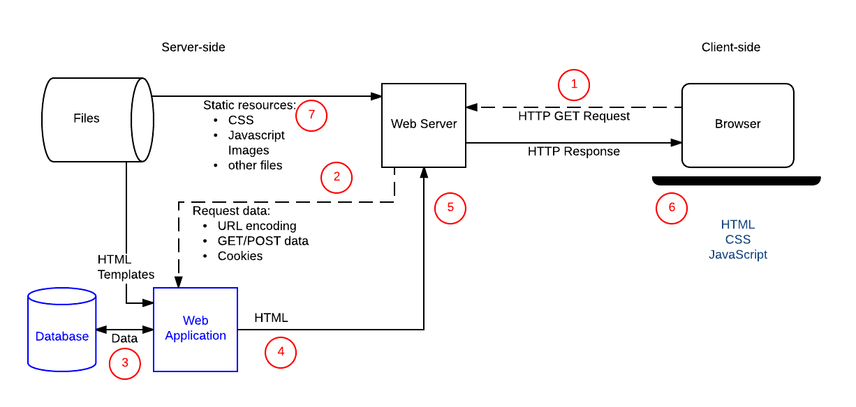

Solution Architecture 4

TECHNICAL ARCHITECTURE

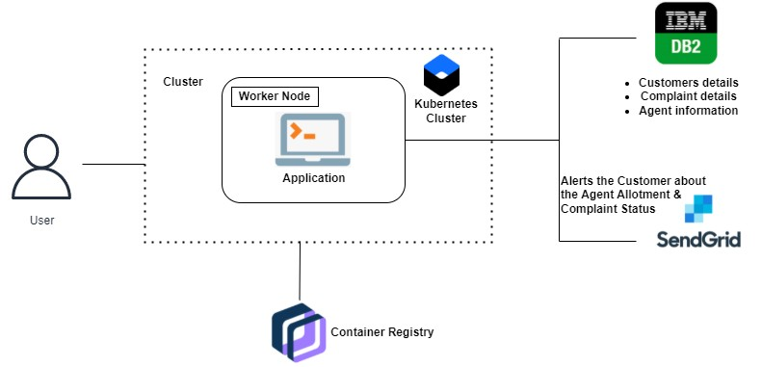

Solution Architecture 5



**Thank you**